Creating EC2 instance using AWS Management Console

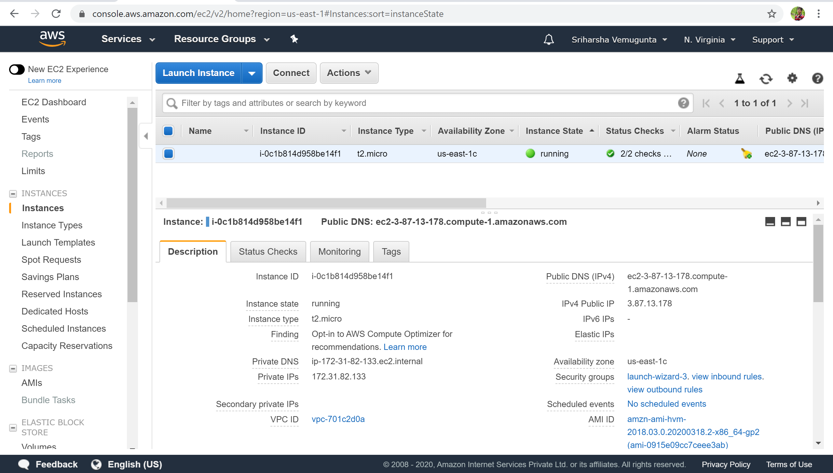

AWS CLI commands to create cloud resources.

1. Creating queue using SQS service.

aws sqs create-queue --queue-name Messages

aws rds create-db-instance --db-name STUDENTDB --engine MySQL --db-instance-identifier mysqlserver --backup-retention-period 0 --db-instance-class db.t2.micro --allocated-storage 5 --publicly-accessible --master-username admin --master-user-password password

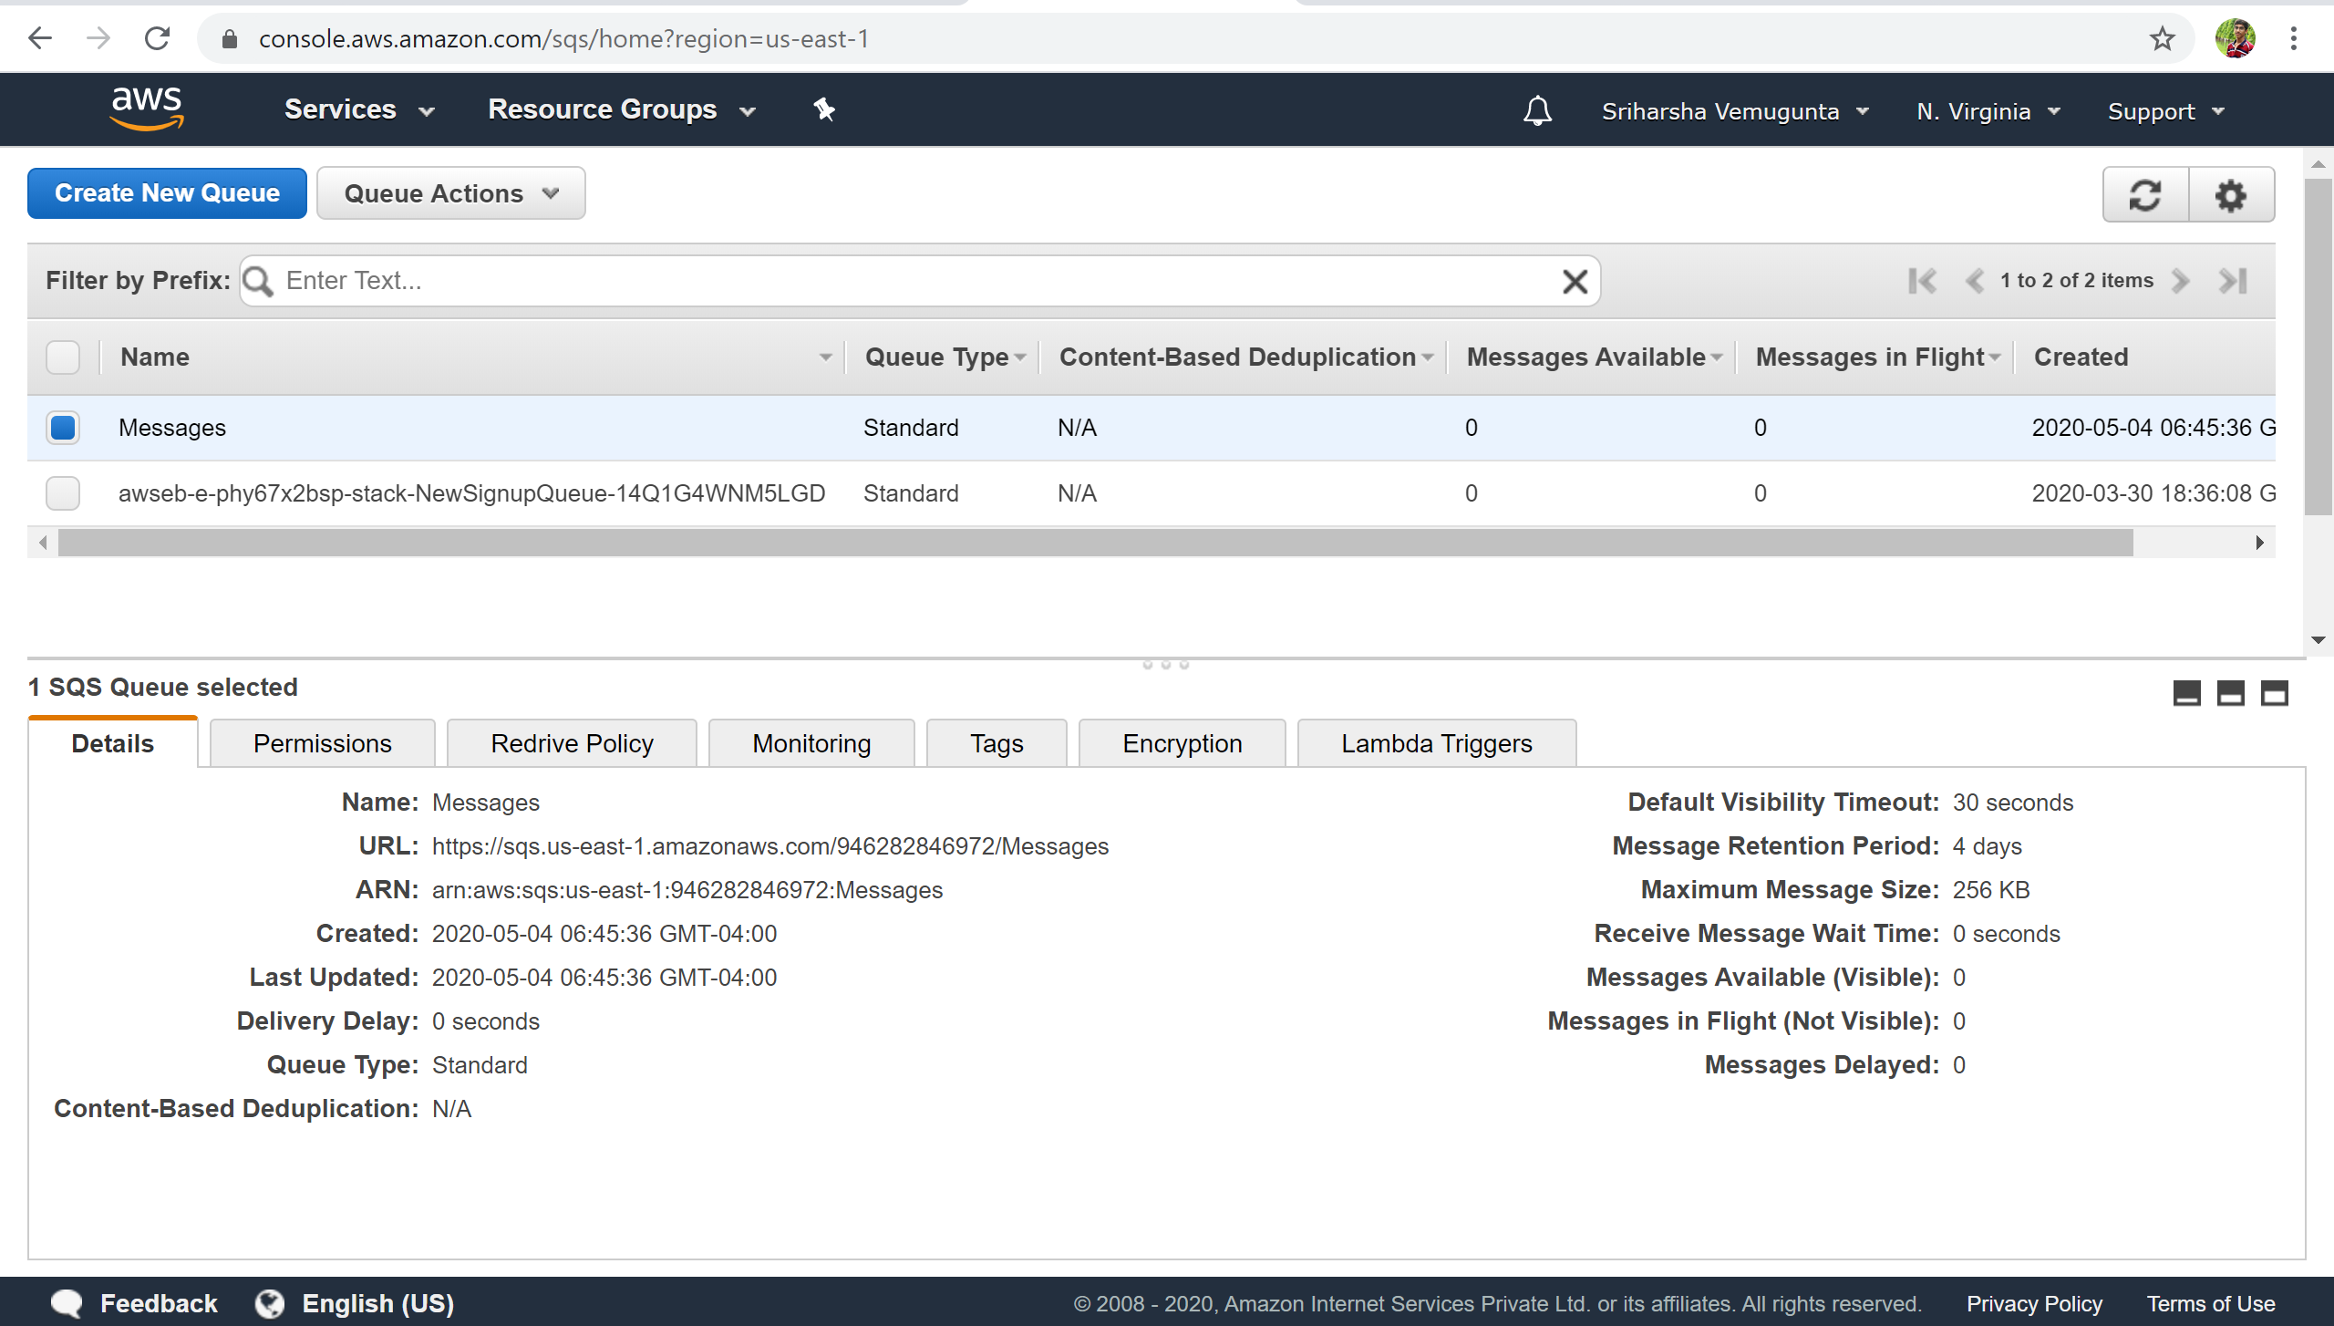

2. Creating RDS instance using AWS management console and using endpoint to create databases in the RDS instance using AWS CLI commands.

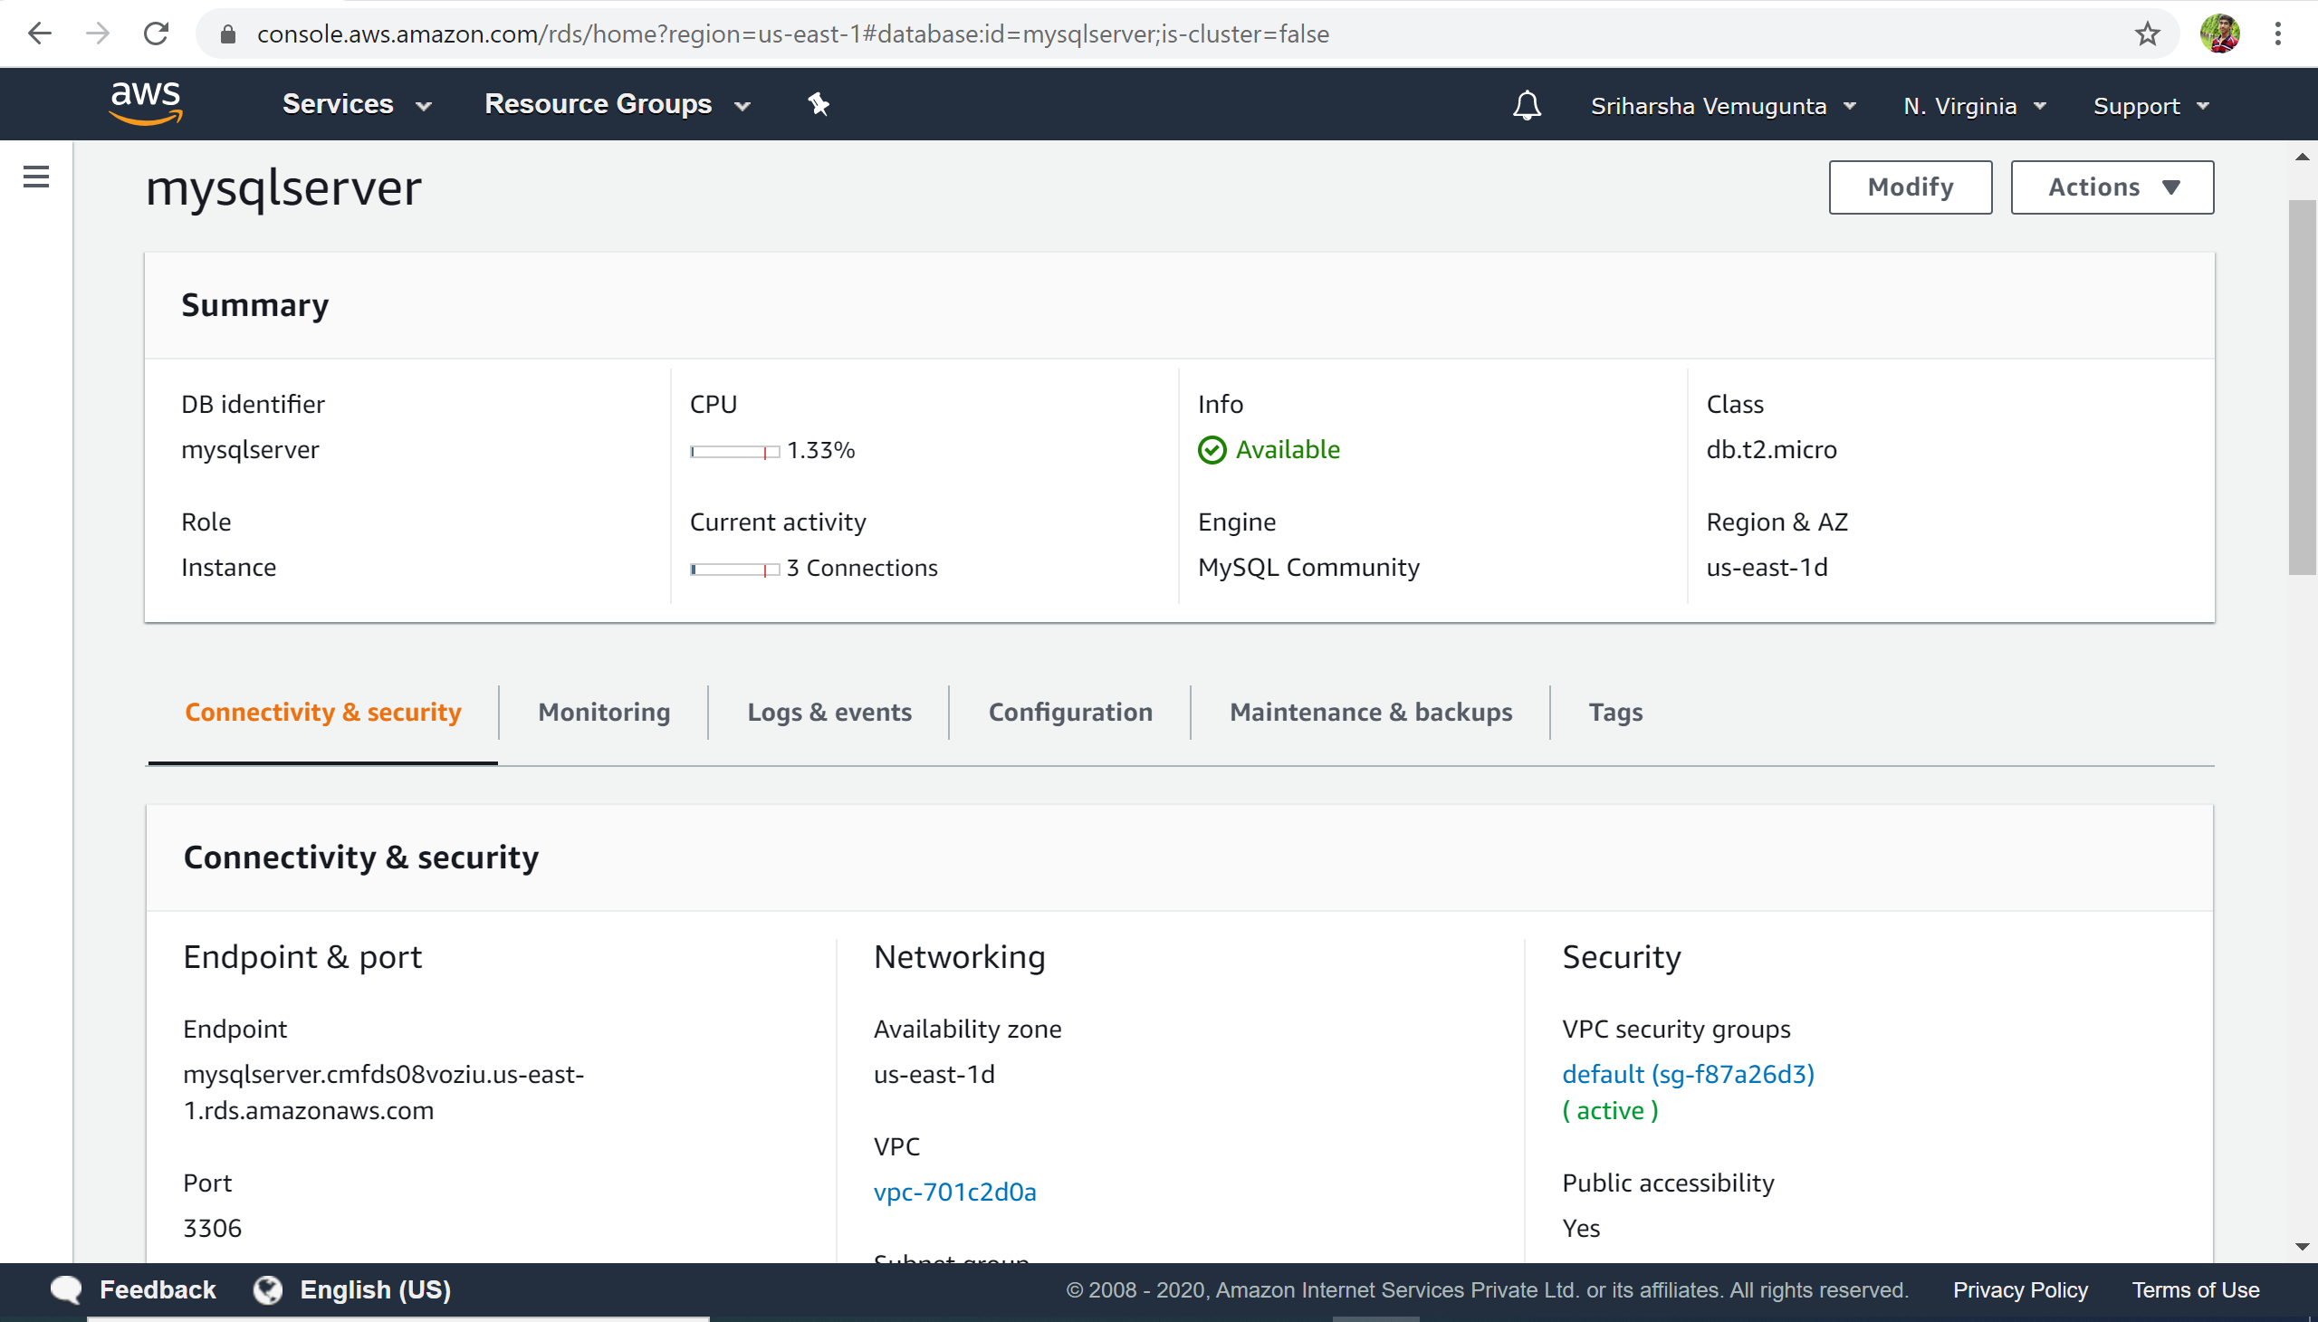

mysql -h mysqlserver.cmfds08voziu.us-east-1.rds.amazonaws.com -P 3306 -u admin -p

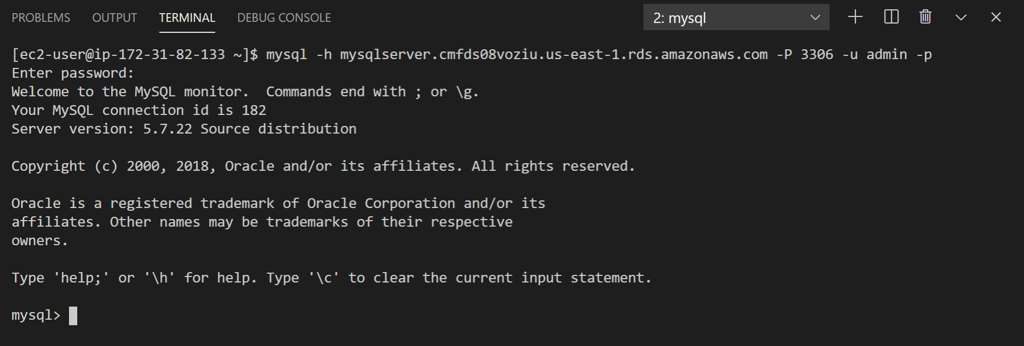

3.Create IAM role for Lambda Function and attaching some policies.

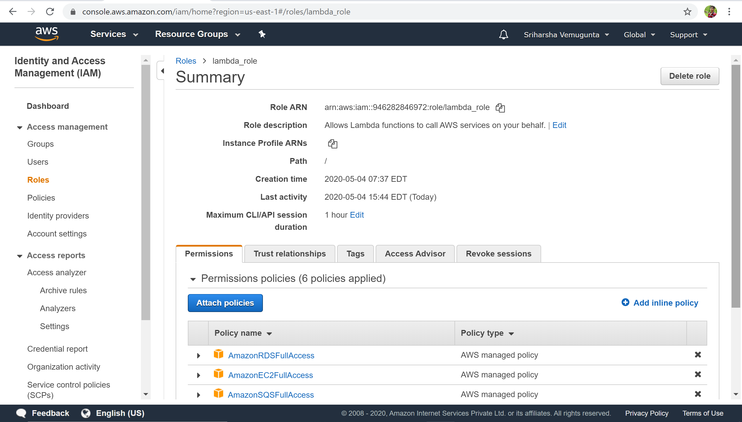

4.Creating Lambda Function

aws lambda create-function --function-name writefunction --runtime python3.7

--zip-file fileb://function.zip --handler write_function.handler

--role arn:aws:iam::946282846972:role/lambda_role

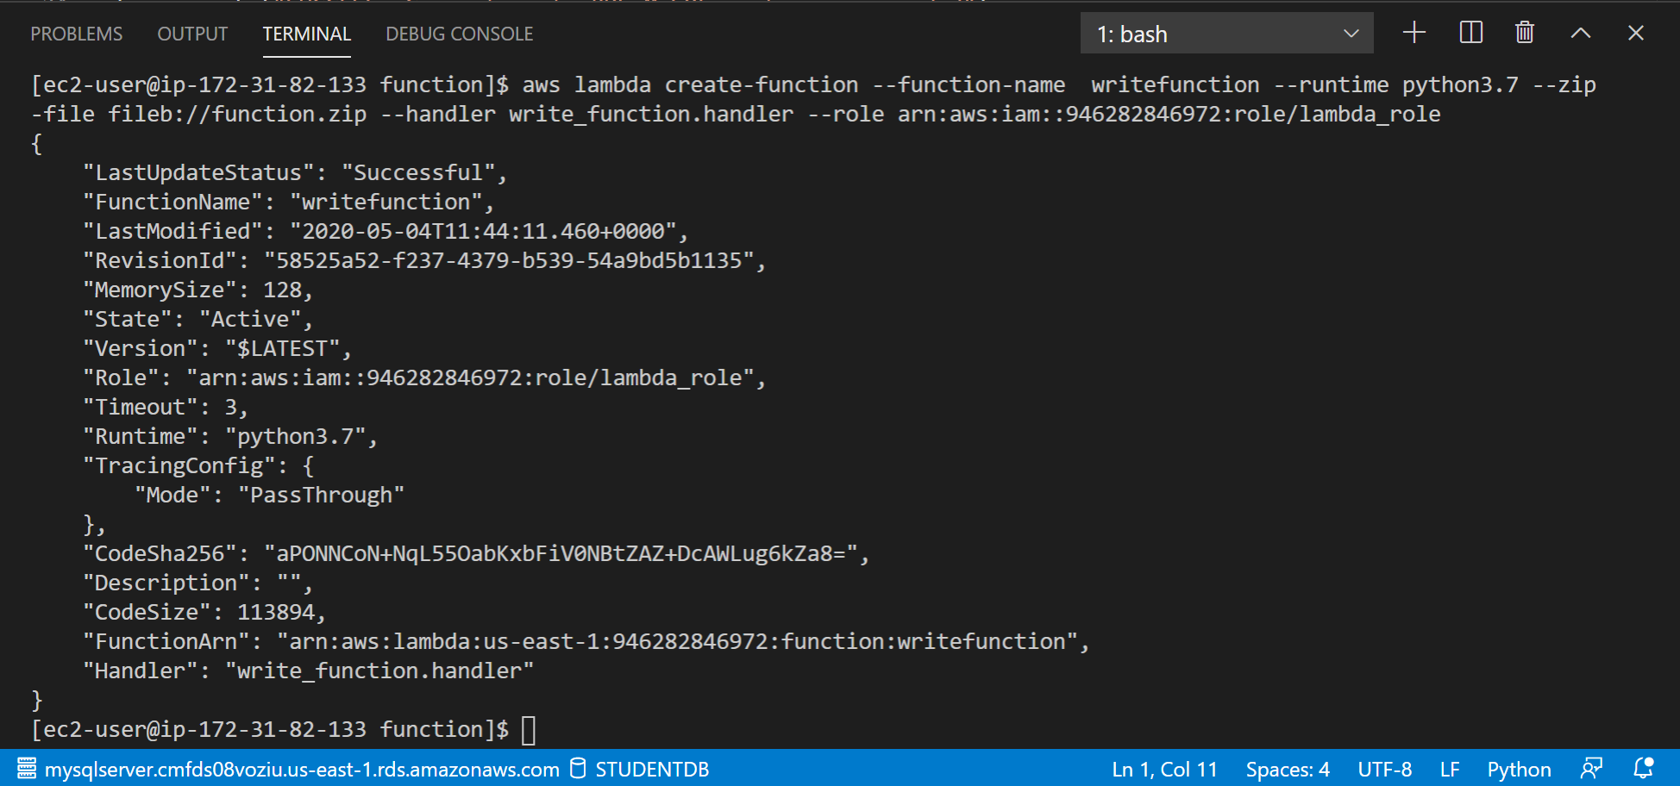

We assume that Students have access to the courses list before hand  
So, we create the database courses and insert the list of courses.

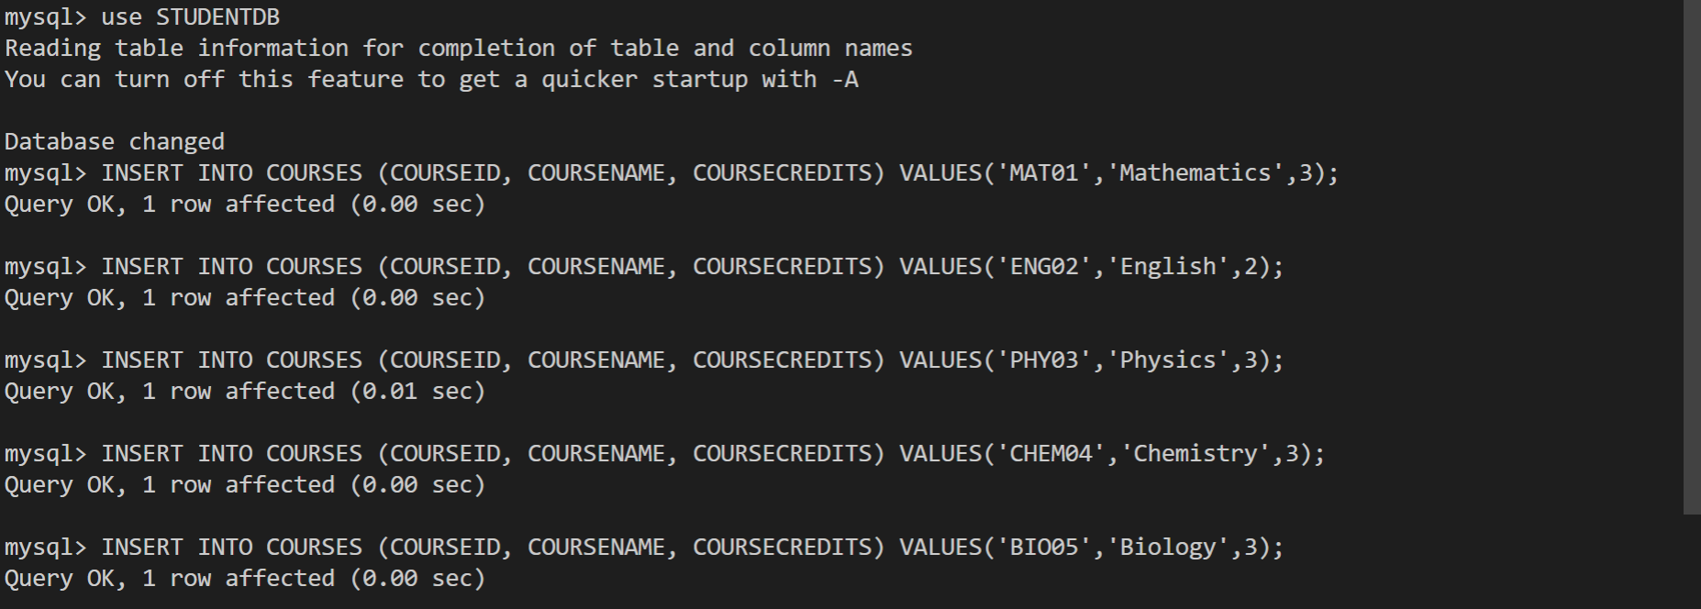

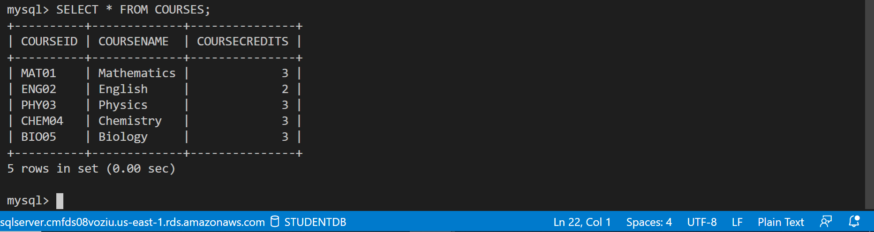

Postman Authorization

Providing the AccessKey, SecretKey, AWS Region and Service Name.

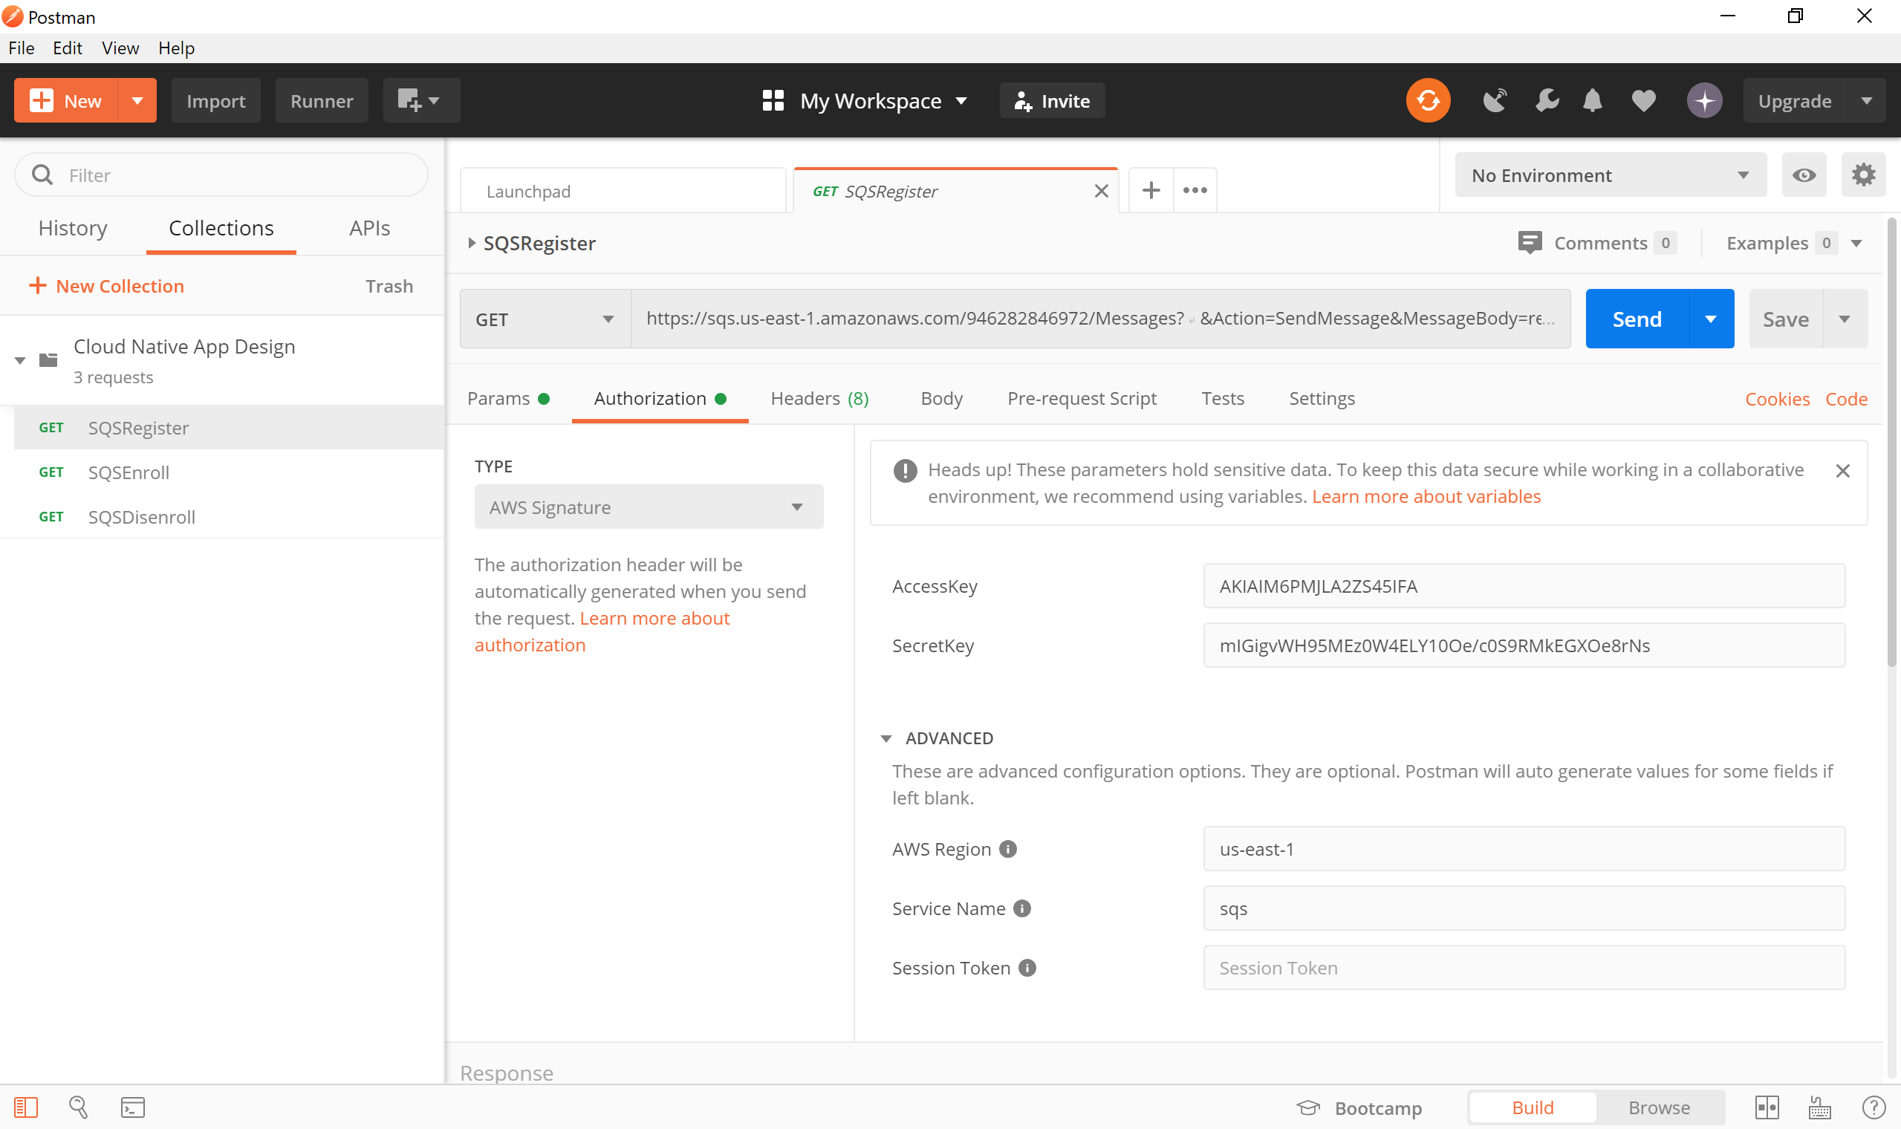

We assume that the students already have their Student ID’s.

Sending the message to register.

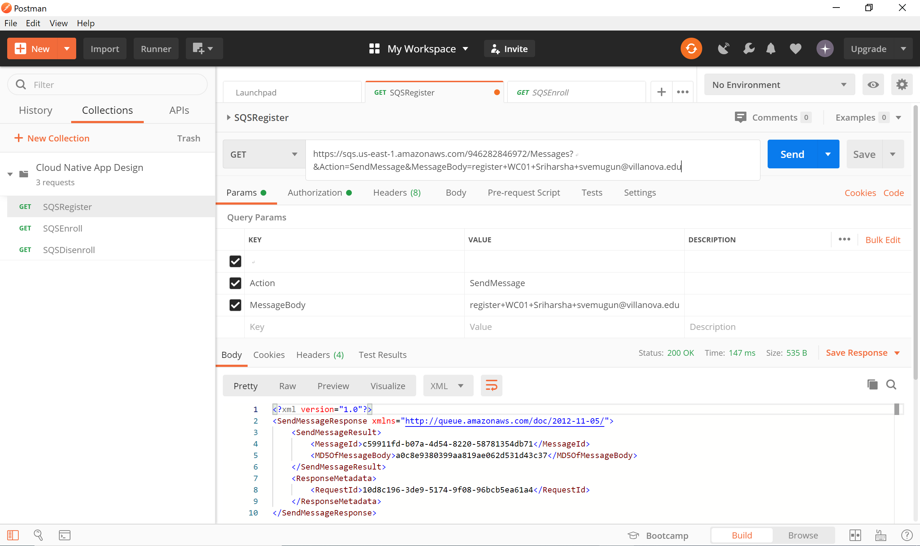

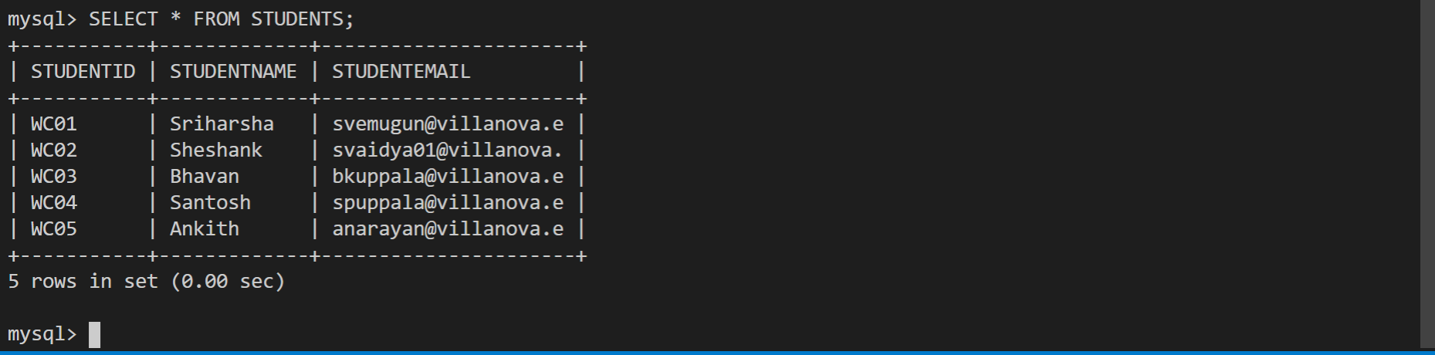

Enrolling in Courses by letting the students know that they can only register in 2 courses.

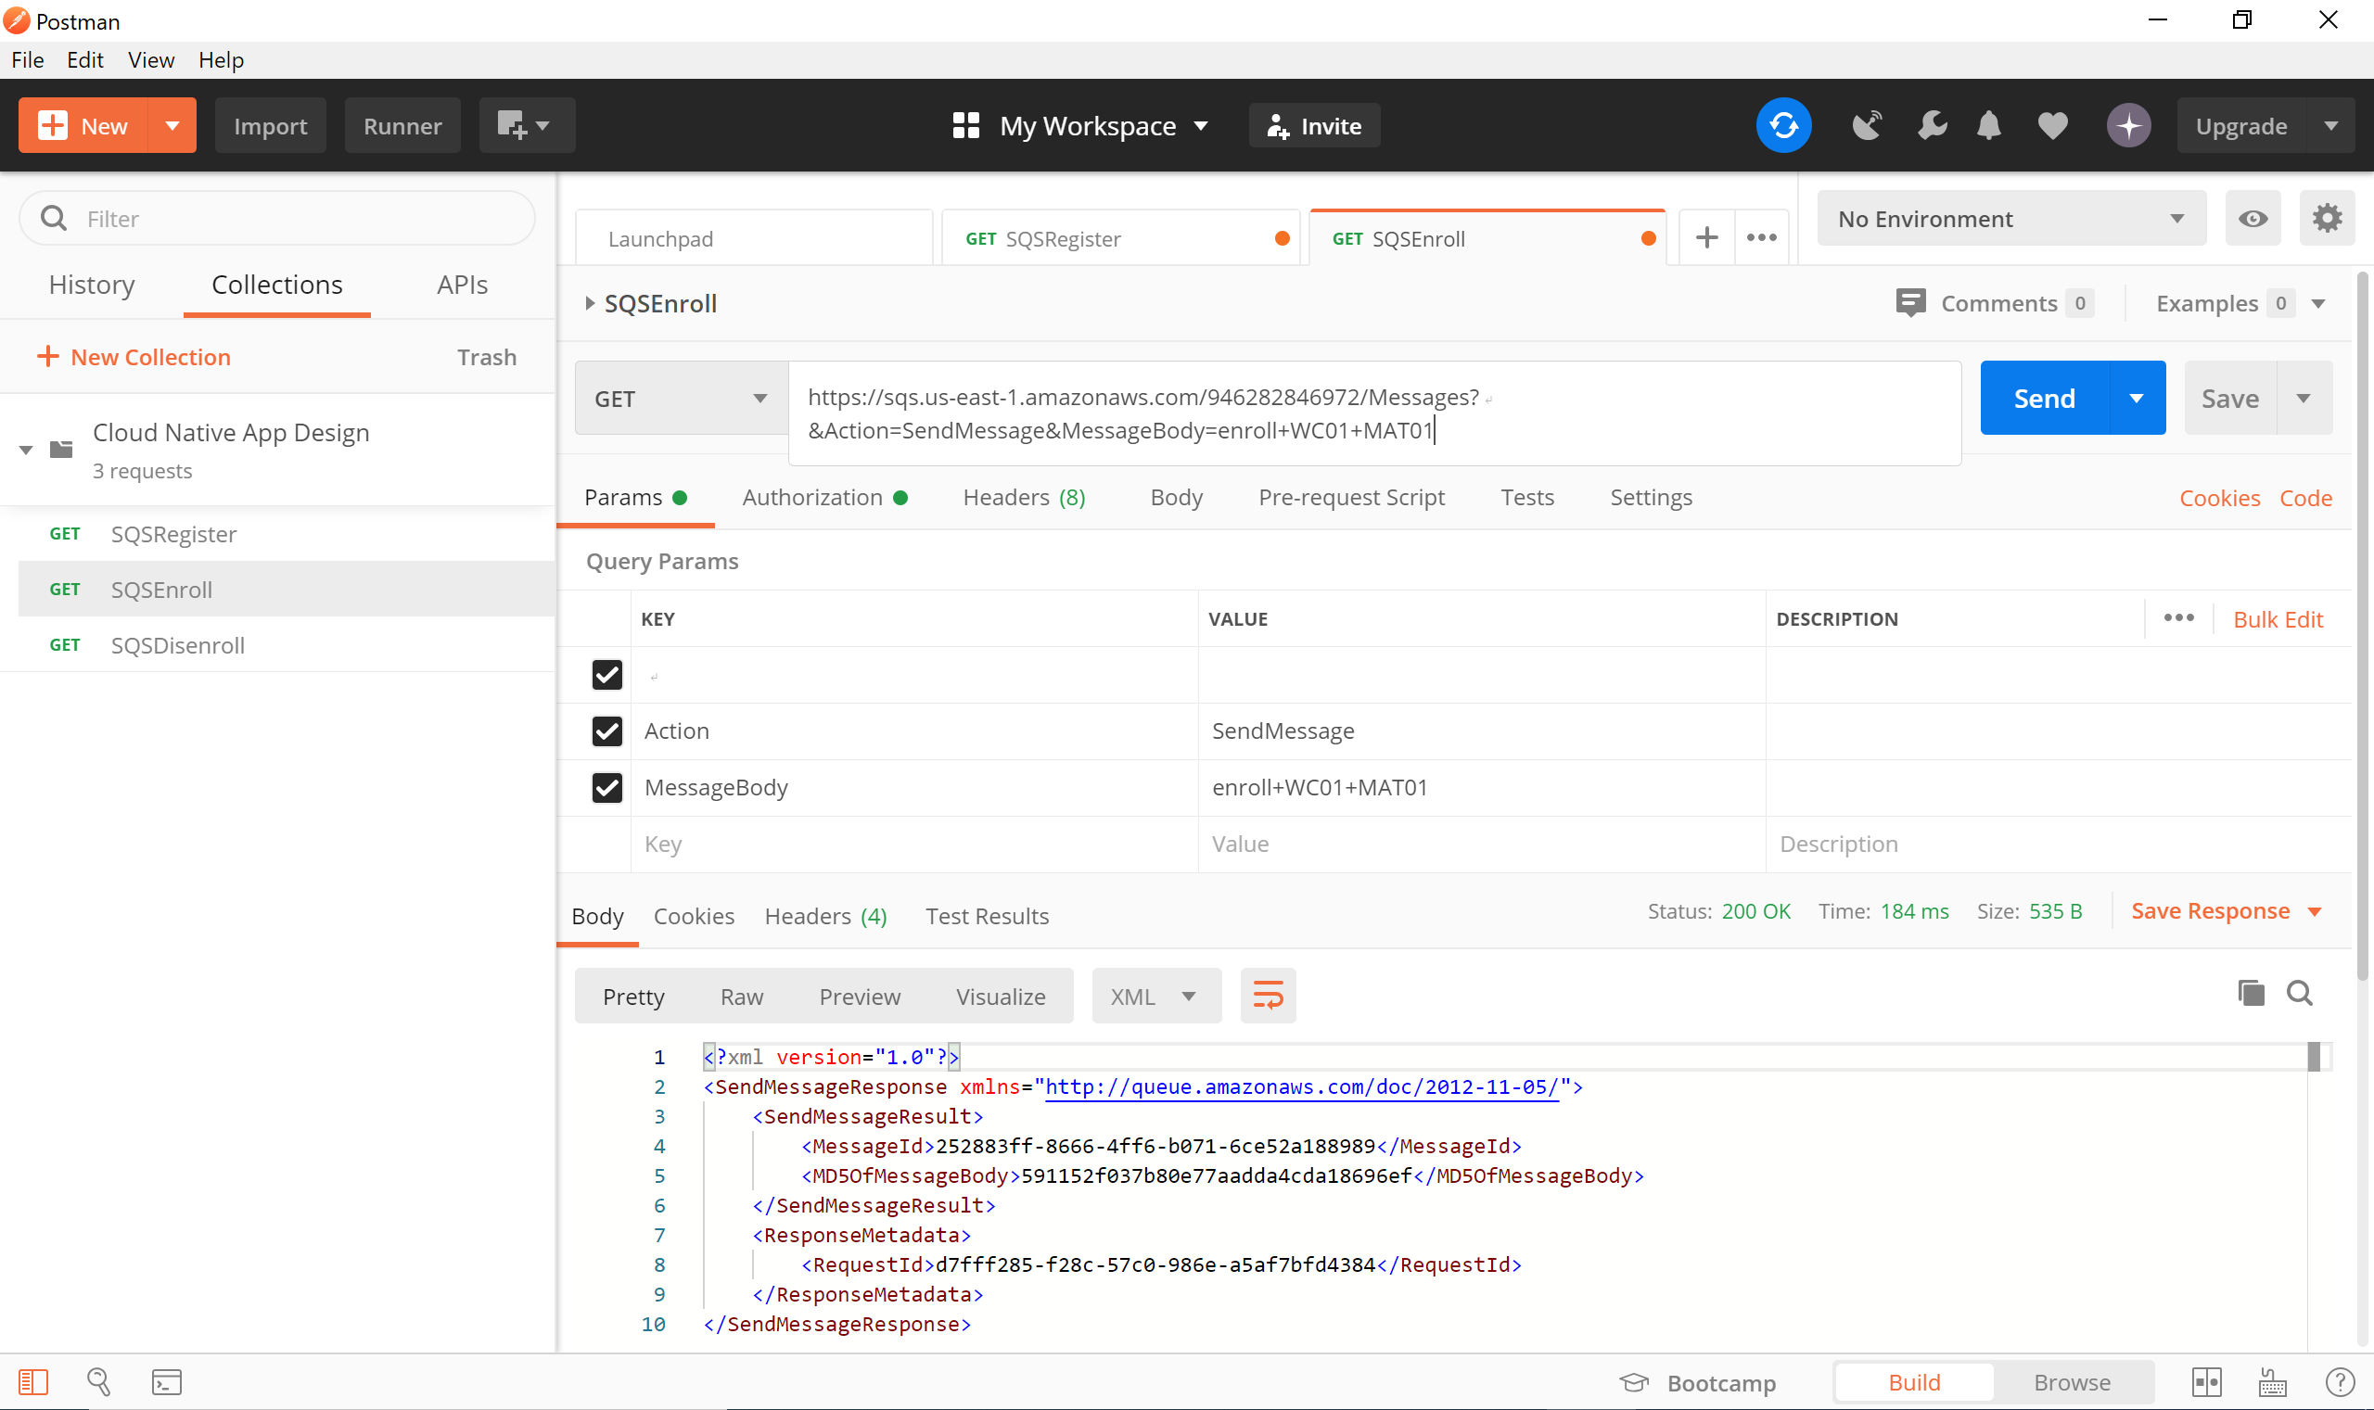

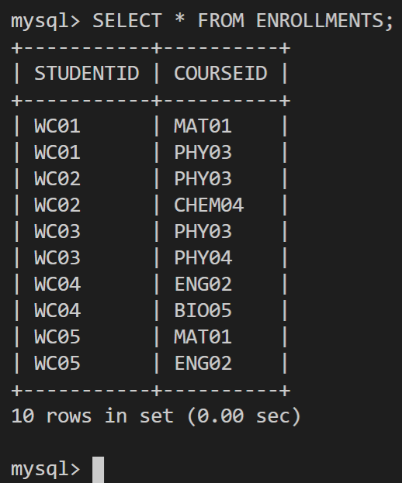

Disenrolling Students from Courses

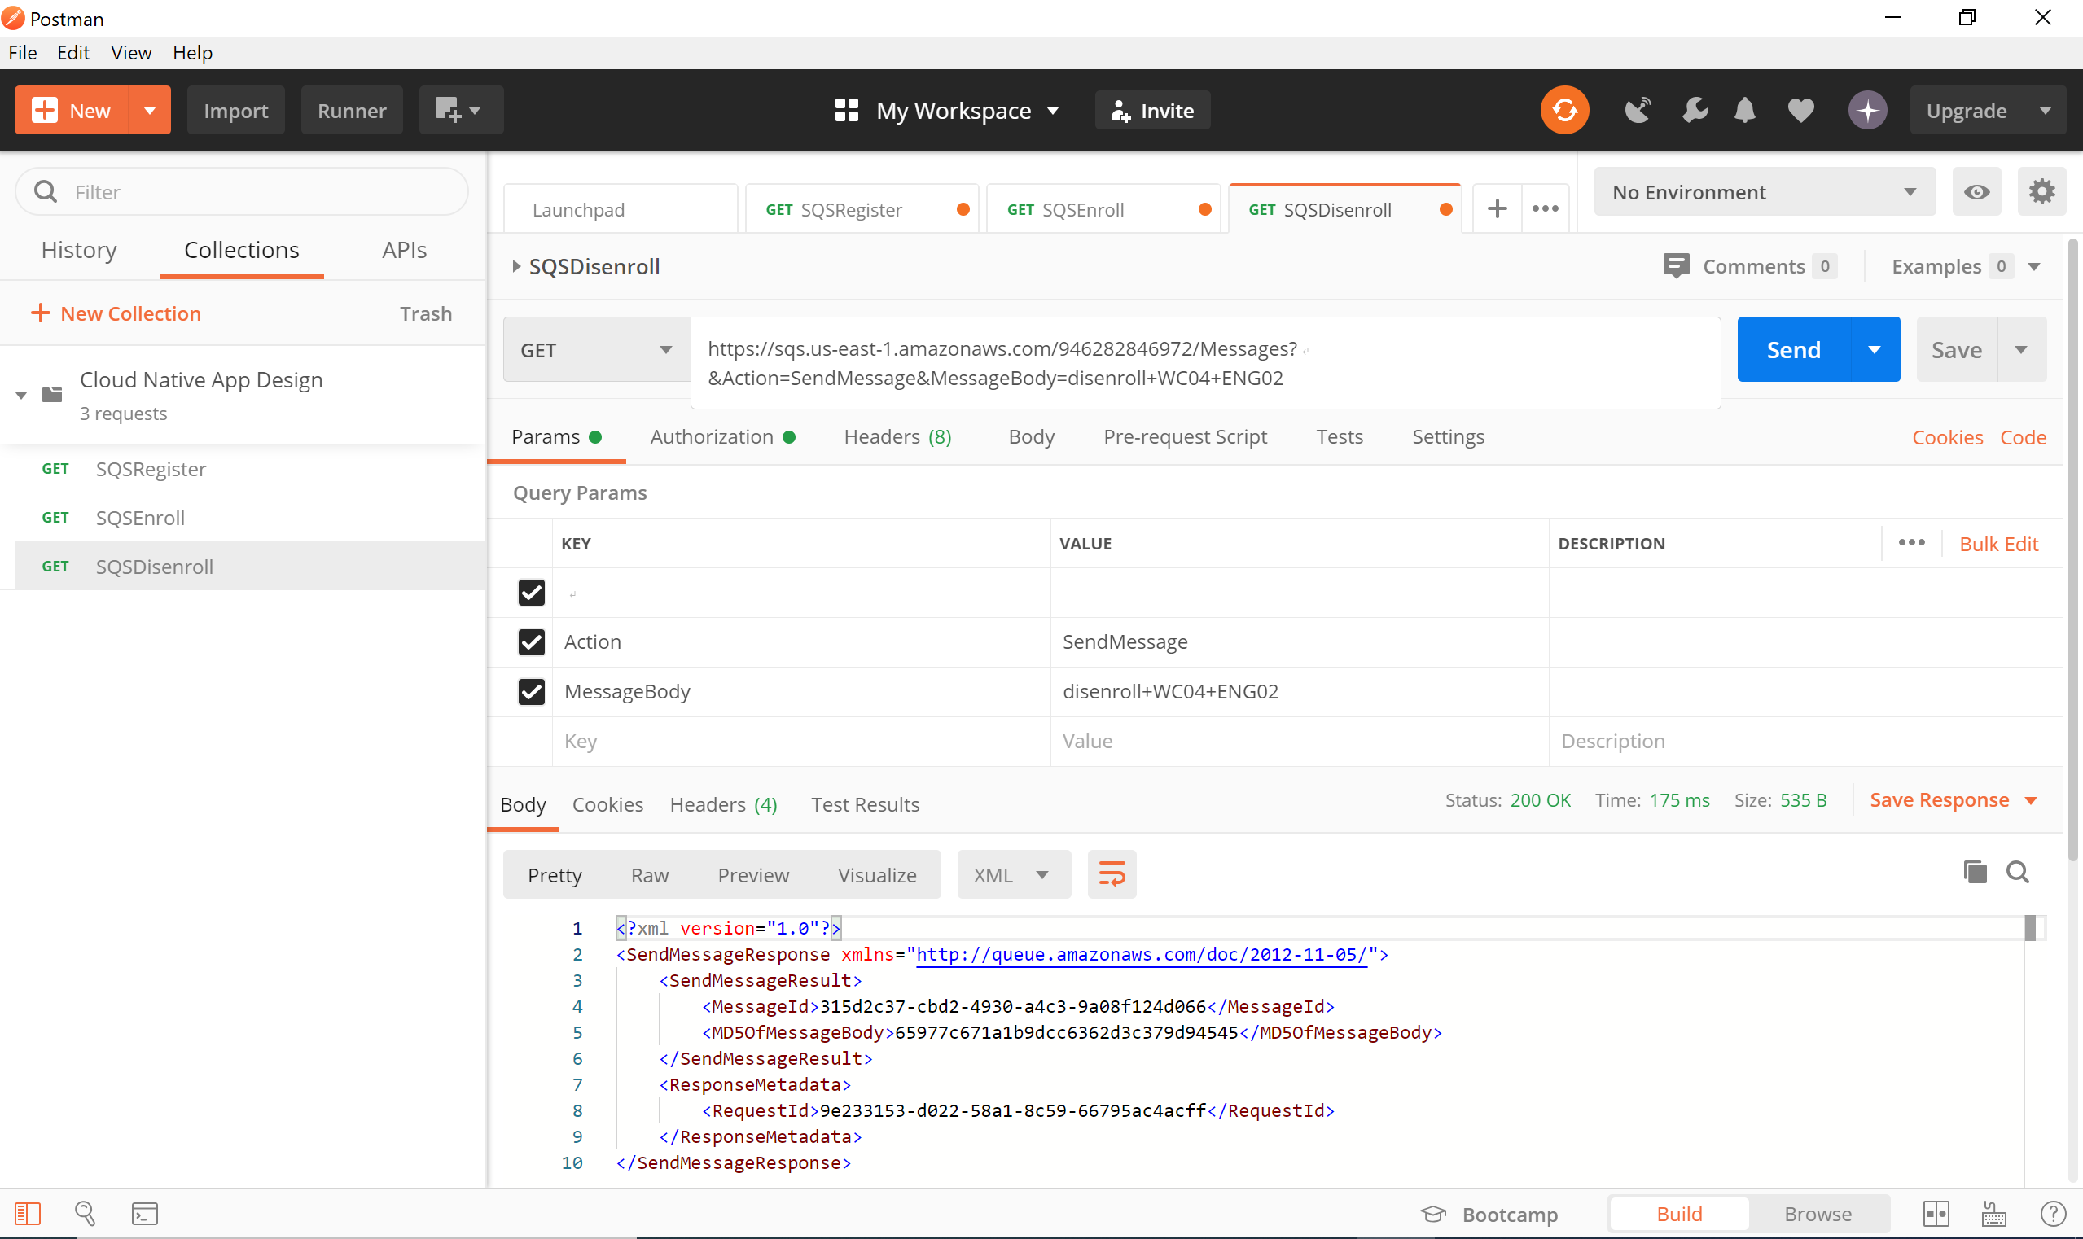

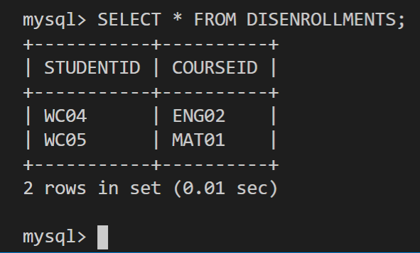

Displaying output

To display the Student List

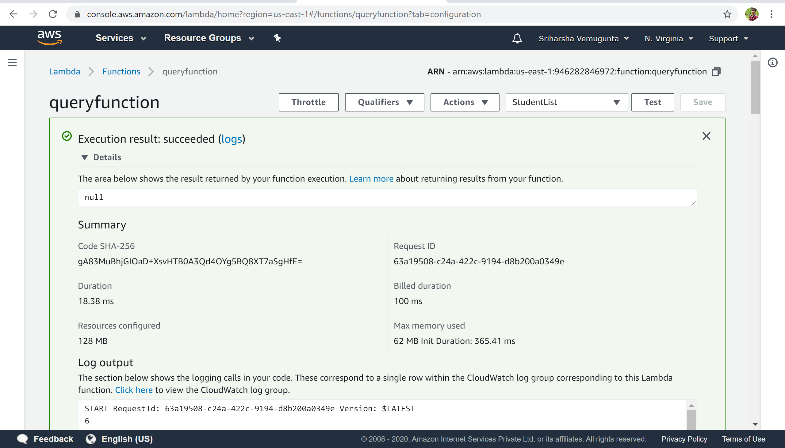

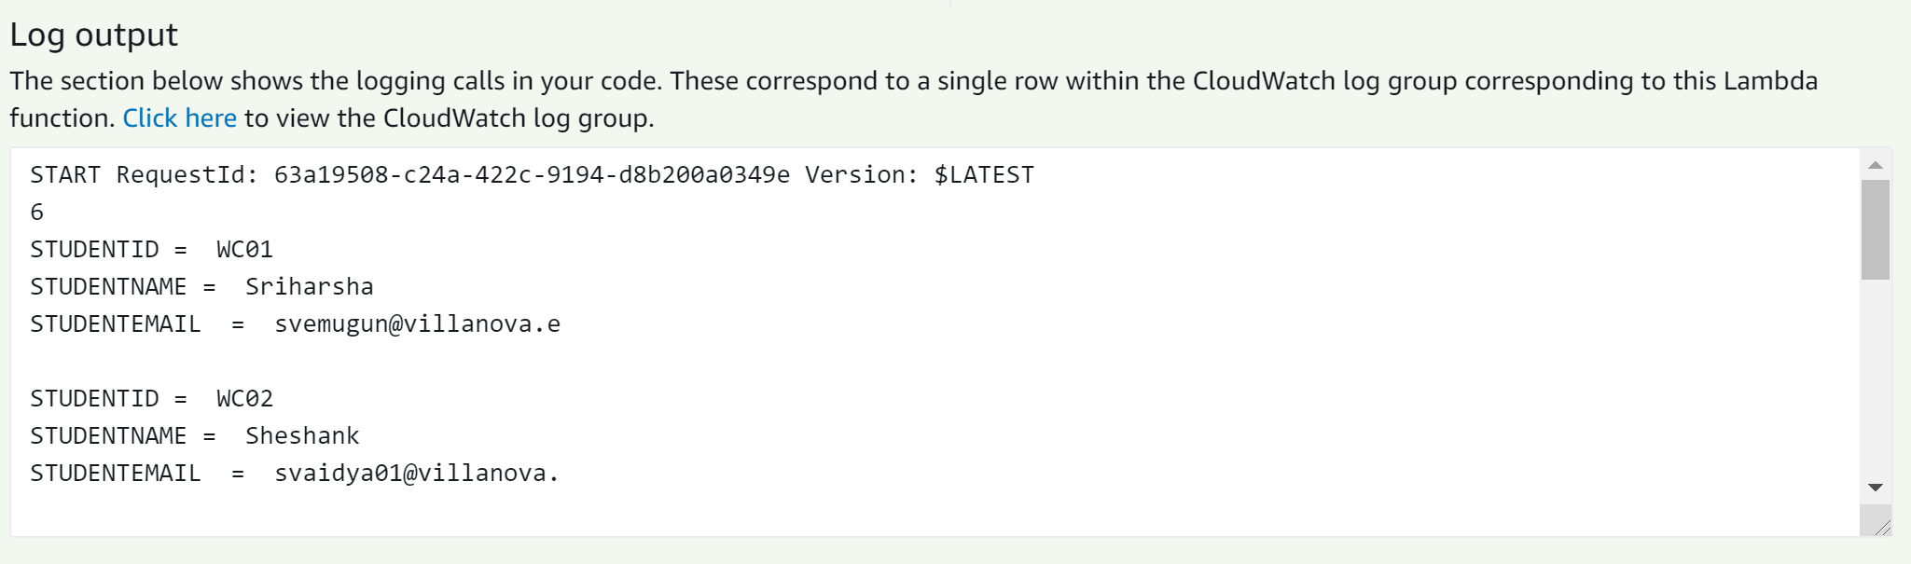

Entire Log Output:

START RequestId: 63a19508-c24a-422c-9194-d8b200a0349e Version: $LATEST

6

STUDENTID = WC01

STUDENTNAME = Sriharsha

STUDENTEMAIL = svemugun@villanova.e

STUDENTID = WC02

STUDENTNAME = Sheshank

STUDENTEMAIL = svaidya01@villanova.

STUDENTID = WC03

STUDENTNAME = Bhavan

STUDENTEMAIL = bkuppala@villanova.e

STUDENTID = WC04

STUDENTNAME = Santosh

STUDENTEMAIL = spuppala@villanova.e

STUDENTID = WC05

STUDENTNAME = Ankith

STUDENTEMAIL = anarayan@villanova.e

STUDENTID = WC06

STUDENTNAME = Bhavya

STUDENTEMAIL = bvemugun@villanova.e

END RequestId: 63a19508-c24a-422c-9194-d8b200a0349e

REPORT RequestId: 63a19508-c24a-422c-9194-d8b200a0349e Duration: 18.38 ms Billed Duration: 100 ms Memory Size: 128 MB Max Memory Used: 62 MB Init Duration: 365.41 ms

To retrieve the Courses in which the student is enrolled

